Electricity Access and Economic Growth in Africa
Panel Evidence with Cameroon as Reference

NGEYEN DORCAS BONJE
5 January 2026

Table of Contents
Electricity Access and Economic Growth in Africa 1
Abstract 4
1. Introduction 4
2. Problem Statement and Motivation 5
3. Data and Variables 5
3.1 Data Sources 5
3.2 Variables 5
4. Descriptive Analysis 6
4.1 Summary Statistics 6
4.2 Correlation Analysis 6
5. Methodology 6
6. Results 7
6.1 Final Regression Results 7
6.2 Country Effects (Baseline: Cameroon) 7
6.3 Visual Analysis 8
7. Discussion 11
8. Correlation vs Causation 11
9. Policy Recommendations 11
10. Conclusion 11
References 12

List of Figures
Figure 1: Trends in electricity access (%) across selected African countries, 1990–2023. 8
Figure 2: Scatter plot of electricity access and log GDP per capita for Cameroon. 9
Figure 3: Relationship between electricity access and economic performance across countries. 9
Figure 4: Electricity access and log GDP per capita across all countries and years, with fitted linear trend. 10
Figure 5: Histogram of regression residuals from the log GDP per capita model. 10

List of Tables
Table 1: Summary statistics for GDP per capita and electricity access 6
Table 2: OLS regression results with log GDP per capita (clustered standard errors) 7

Abstract
Access to electricity is a critical driver of economic development, yet large disparities persist across Sub-Saharan Africa. This study examines the relationship between electricity access and economic growth using panel data for Cameroon, Côte d’Ivoire, Ghana, and Nigeria from 1990 to 2023. Employing Ordinary Least Squares (OLS) models with country- and year-fixed effects, clustered standard errors, and a log-transformed GDP per capita specification, the analysis finds a positive and economically meaningful association between electricity access and income levels. The final model indicates that a 1% point increase in electricity access is associated with approximately a 2.8% increase in GDP per capita. These findings reinforce the importance of expanding electricity infrastructure as a key component of the region's long-term economic growth strategies.
Keywords: Electricity access, economic growth, GDP per capita, panel data, Sub-Saharan Africa

Introduction
Electricity access is widely regarded as a foundational input for economic activity, enabling industrial production, service delivery, technological adoption, and improvements in household welfare. In Sub-Saharan Africa, electricity access remains significantly below global averages, despite steady progress over the past three decades (World Bank, 2023). Countries within the region exhibit substantial disparity in electrification rates and economic performance, suggesting that electricity access may play a meaningful role in shaping growth trajectories.
This study analyzes the relationship between electricity access and economic growth in four West and Central African countries: Cameroon, Côte d’Ivoire, Ghana, and Nigeria, from 1990 to 2023. The econometric models are systematically refined to provide robust and interpretable evidence regarding the association between electricity access and GDP per capita.

Problem Statement and Motivation
Limited access to reliable electricity has been identified as a major constraint on economic development in Sub-Saharan Africa. According to the World Bank (2023), nearly 600 million people in the region lack access to electricity, with adverse implications for productivity, firm performance, and human capital accumulation. The International Energy Agency (IEA, 2022) further highlights that inadequate power infrastructure increases production costs and discourages private investment.
Empirical studies support these concerns. For example, Calderón and Servén (2010) find that infrastructure development, including electricity, has a positive and significant impact on economic growth in developing countries. Similarly, Foster and Steinbuks (2009) show that power shortages substantially reduce firm-level productivity in Africa.
Despite this evidence, the magnitude and robustness of the relationship between electricity access and income growth across countries and over time remain an empirical question. This study contributes to the literature by providing panel-based estimates that control for country-specific characteristics and common time shocks.

Data and Variables

Data Sources
- GDP per capita (constant prices): World Bank World Development Indicators (World Bank, 2024)
- Electricity access (% of population): World Development Indicators (World Bank, 2023)
- Country and year identifiers

Variables
- Dependent variables:
  - GDP per capita
  - Log of GDP per capita (final specification)
- Main explanatory variable:
  - Electricity access (% of population)
- Control variables:
  - Country fixed effects
  - Year fixed effects

Descriptive Analysis

Summary Statistics

Variables | elec_access | gdp_pc
count | 128 | 128
mean | 53.37533 | 1413.537097
std | 13.39323 | 704.754371
min | 27.3 | 253.746936
max | 89.5 | 3189.812865
Table 1: Summary statistics for GDP per capita and electricity access

Correlation Analysis
Correlation coefficient between electricity access and GDP per capita:
$$ρ ≈0.676$$
Interpretation
The results indicate a strong positive linear association between electricity access and GDP per capita. Countries and years with higher electricity access consistently exhibit higher income levels.

Methodology
The empirical analysis employs a stepwise approach, incrementally refining model specifications to enhance both the validity of inference and the clarity of interpretation.
The baseline model estimates a pooled OLS regression of GDP per capita on electricity access. While informative, this specification does not account for unobserved heterogeneity across countries or common shocks over time.
To address this limitation, country fixed effects are introduced to control for time-invariant characteristics such as geography, institutional quality, and historical development paths. Year fixed effects are subsequently added to capture global and regional shocks affecting all countries simultaneously.
Given the panel structure of the data, standard errors are clustered at the country level to account for serial correlation and heteroskedasticity within countries over time.
GDP per capita is ultimately transformed using the natural logarithm. This log-linear specification reduces the influence of extreme values and allows coefficients to be interpreted as approximate percentage changes.

Results

Final Regression Results

Variable | Coef. | Std. Err. | p-value
Intercept (Cameroon, baseline country) | 5.3121 | 0.428 | 0.000
Côte d’Ivoire (relative to Cameroon) | −0.0197 | 0.073 | 0.788
Ghana (relative to Cameroon) | −0.5586 | 0.110 | 0.000
Nigeria (relative to Cameroon) | 0.2516 | 0.018 | 0.000
Electricity access (%) | 0.0278 | 0.015 | 0.064
Table 2: OLS regression results with log GDP per capita (clustered standard errors)
- R-squared: 0.855
- Adjusted R-squared: 0.796
- Number of observations: 128
Electricity access coefficient:
$$β=0.0278 (p=0.064)$$
Interpretation
A one-percentage point increase in electricity access is associated with an estimated 2.8% increase in GDP per capita, holding country and year effects constant. The coefficient is statistically significant at the 10% level, supporting a positive and economically meaningful relationship.

Country Effects (Baseline: Cameroon)
Cameroon serves as the reference country in the fixed-effects specification.
- Ghana (Coefficient = –0.5586 (p < 0.01))
Ghana’s GDP per capita is approximately 44% lower than Cameroon’s, holding electricity access and time effects constant.
- Nigeria (Coefficient = 0.2516 (p < 0.01))
Nigeria’s GDP per capita is approximately 28.6% higher than Cameroon’s, all else equal.
- Côte d’Ivoire (Coefficient = –0.0197 (p = 0.788))
No statistically significant difference relative to Cameroon.
These estimates highlight persistent structural income differences across countries that are not explained solely by electricity access.

Visual Analysis

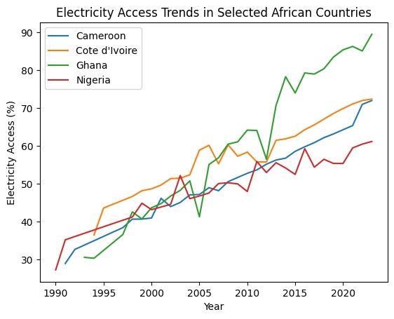
Figure 1: Trends in electricity access (%) across selected African countries, 1990–2023.
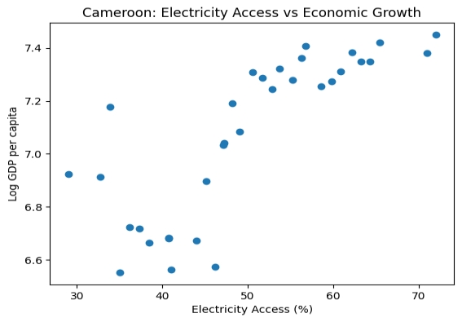
Figure 2: Scatter plot of electricity access and log GDP per capita for Cameroon.

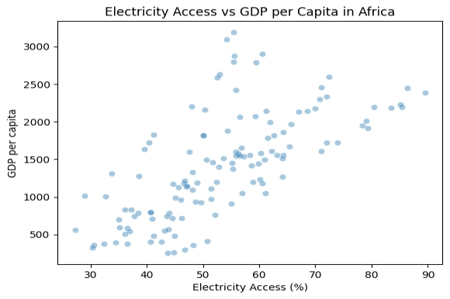
Figure 3: Relationship between electricity access and economic performance across countries.
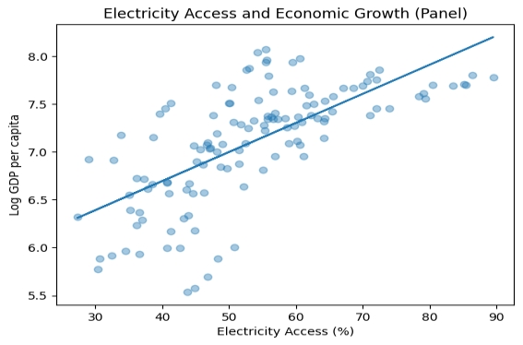
Figure 4: Electricity access and log GDP per capita across all countries and years, with fitted linear trend.
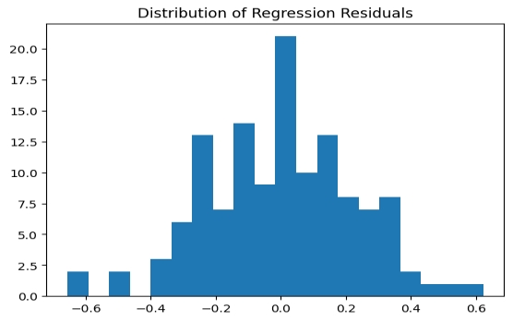
Figure 5: Histogram of regression residuals from the log GDP per capita model.
The residual diagnostics suggest that the residuals are approximately normally distributed, supporting the adequacy of the linear model specification.

Discussion
The results consistently demonstrate a positive association between electricity access and economic growth. Correlation analysis reveals strong co-movement, and fixed-effects regressions confirm that this relationship remains after controlling for country-specific characteristics and time trends. The log-linear model yields economically interpretable estimates, reinforcing the role of electricity as a key input for growth.

Correlation vs Causation
While the results indicate a robust association between electricity access and economic growth, the analysis does not establish causal effects. Potential concerns include:
- Reverse causality: richer countries may invest more in electricity infrastructure.
- Omitted time-varying factors, such as institutional reforms or sector-specific policies.
- Measurement error in infrastructure indicators.
The use of fixed effects and clustered standard errors helps to address these concerns, but does not fully resolve them.

Policy Recommendations
Based on the findings, the following policy recommendations are proposed:
- Accelerate Electricity Infrastructure Expansion
Governments should prioritize investments in generation, transmission, and distribution networks, particularly in underserved regions.
- Improve Reliability, Not Just Access
Expanding access must be complemented by improvements in reliability to ensure sustained productivity gains.
- Target Complementary Reforms
Electricity investments should be paired with industrial and regulatory reforms to maximize economic returns.

Conclusion
The analysis provides robust evidence of a positive association between electricity access and economic growth in selected West and Central African countries. These findings highlight the importance of sustained and inclusive electrification strategies as integral components of broader development policies to promote long-term income growth.

References
Calderón, C., & Servén, L. (2010). Infrastructure and economic development in Sub-Saharan Africa. Journal of African Economies, 19(suppl_1), i13–i87. https://ideas.repec.org/a/oup/jafrec/v19y2010isuppl_1p13-87.html
Foster, V., & Steinbuks, J. (2009). Paying the price for unreliable power supplies: In-house generation of electricity by firms in Africa. World Bank. https://www.researchgate.net/publication/228312215_Paying_the_Price_for_Unreliable_Power_Supplies_In-House_Generation_of_Electricity_by_Firms_in_Africa
International Energy Agency. (2025). Financing electricity access in Africa. IEA. https://www.iea.org/reports/financing-electricity-access-in-africa
World Bank. (2023). Access to electricity (% of population). World Bank Open Data. https://data.worldbank.org/indicator/EG.ELC.ACCS.ZS
World Bank. (2024). GDP per capita (current US$). World Bank Open Data. https://data.worldbank.org/indicator/NY.GDP.PCAP.CD
World Bank. (2025). Power for progress: A call from African leaders and partners to electrify Africa. https://www.worldbank.org/en/news/feature/2025/01/13/power-for-progress-a-call-from-african-leaders-and-partners-to-electrify-africa

